Business Insights Dashboard

SUBJECT: Looker Studio
Instructor Name:
Zeeshan Saleem Sahib

SUBMITTED BY:
Muhammad Fahad Malik

Overview:
In this project I have assigned a task to create a project using Looker Studio (Google Data Studio) to visualize and analyze data in an interactive way. The dashboard contain four pages Overview, Orders Analysis, Customer & Product Insights, and Data Validation. It includes slicers and date range filters that allow users to explore data by different categories, time periods, and regions. Various charts and KPI cards are used to show key insights such as total sales, customer trends, product performance, and overall data quality.
Objective:
The goal of this project is to make data easier to understand through clear visuals, organized layout, and interactive filters, helping users make better decisions based on insights.

1. Pdf File of Project:
Here is the pdf of project :

2. Link of capstone project:
Here is the link of project click here:
3. Link of LinkedIn post:
Here is the link of LinkedIn Post click here:
1. Project screenshots:
Here is the Screenshots of project report.

1. Cover Page:
Here is the screenshot of cover page of my looker studio report:
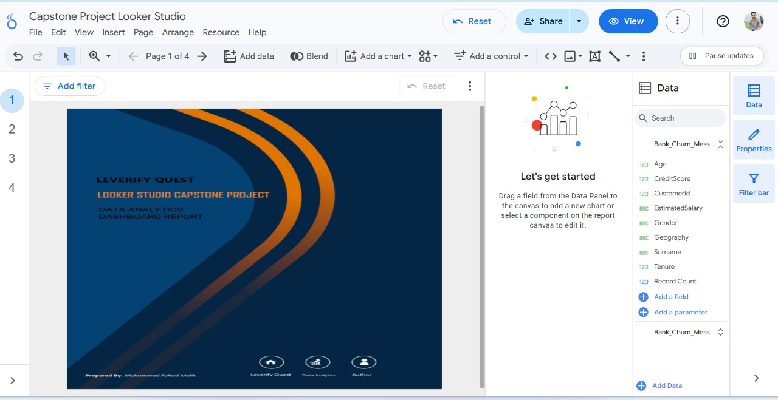

2. Customers Churn & Insights Dashboard:
Here is the screenshot of first page of report:

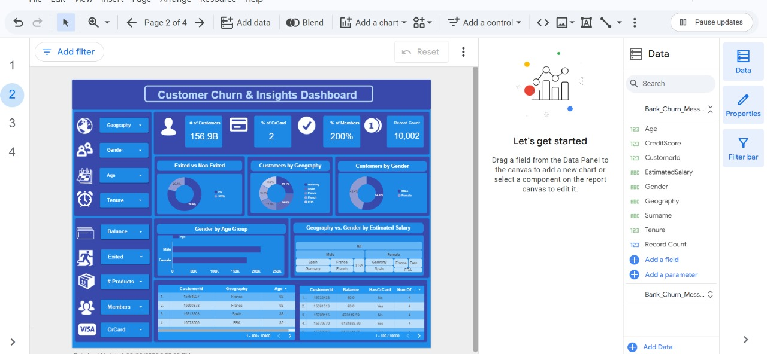

3. Customers & product Engagement Overview:
Here is the screenshot of second page of report:
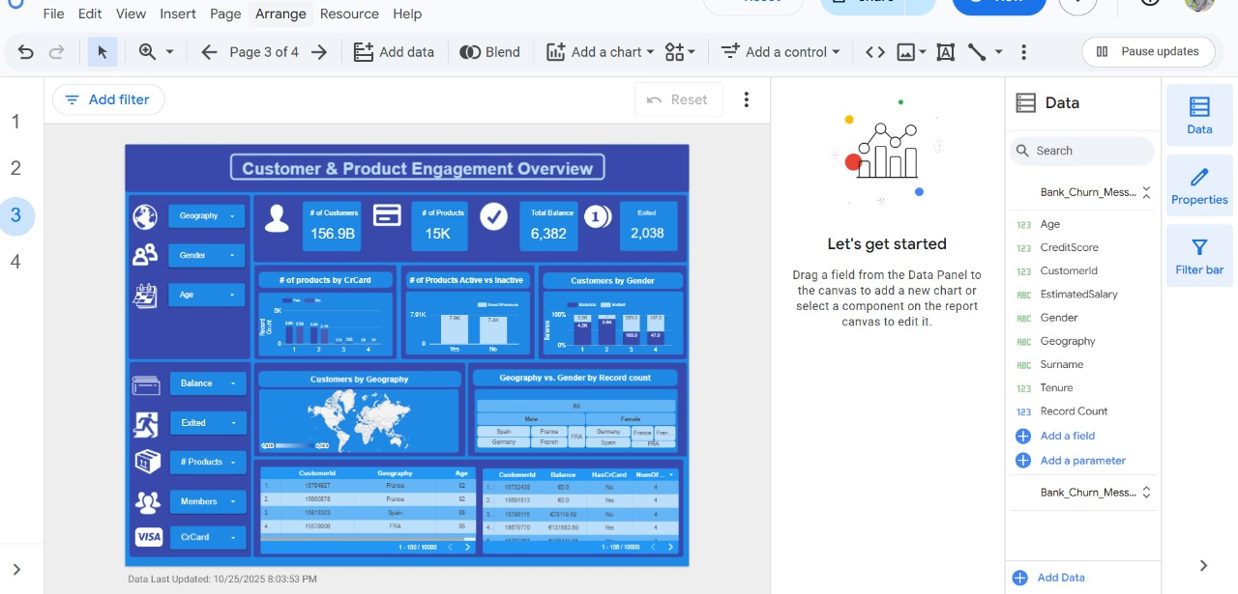

4. Data Quality & Validation Overview:
Here is the screenshot of third page of report:

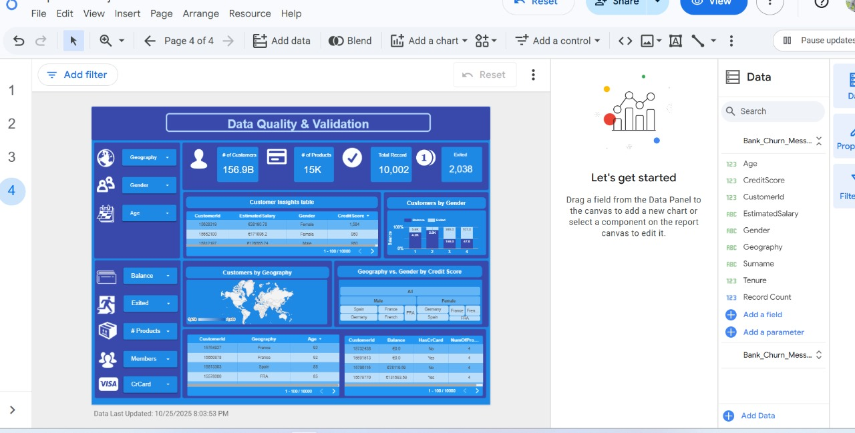

5. Data Quality & Validation Overview:
Here is the screenshot of LinkedIn Post:
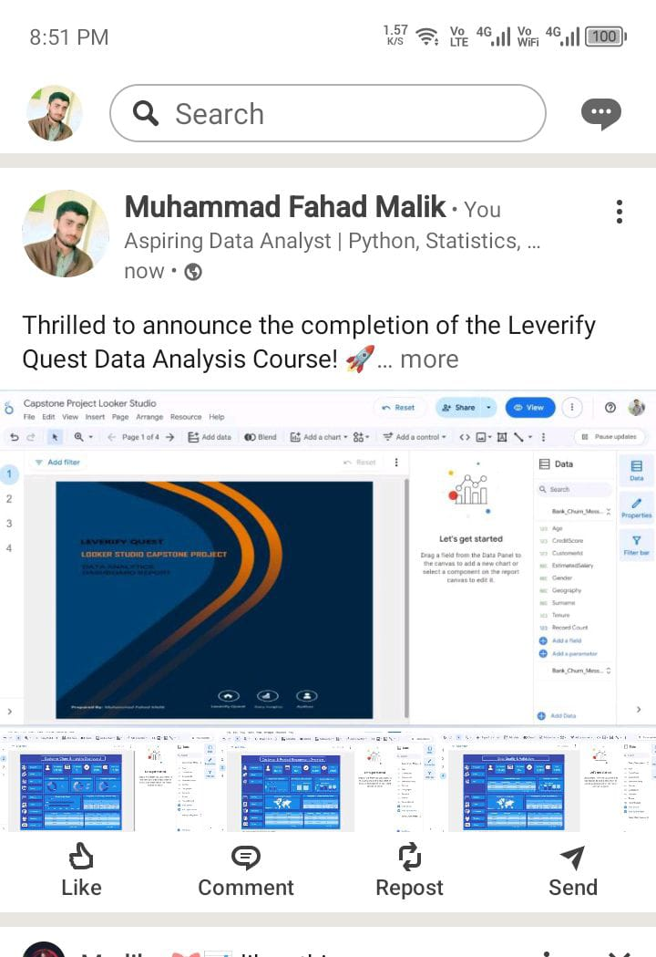

Questions:

